Supplementary information

Distinct Actions of the Fermented Beverage Kefir on Host Behaviour, Immunity and Microbiome Gut-Brain Modules in the Mouse

Marcel van de Wouw^{1,2*}, Aaron M. Walsh^{1,3,5*}, Fiona Crispie^{1,3}, Lucas van Leuven¹, Joshua M. Lyte¹, Marcus Boehme¹, Gerard Clarke^{1,4}, Timothy G. Dinan^{1,4}, Paul D. Cotter^{1,3$}, John F. Cryan^{1,2,4$}

*Shared first co-author
$Shared last co-author

¹APC Microbiome Ireland, University College Cork, Cork, Ireland
²Department of Anatomy and Neuroscience, University College Cork, Cork, Ireland
³Teagasc Food Research Centre, Moorepark, Fermoy, Cork, Ireland.
⁴Department of Psychiatry and Neurobehavioral Science, University College Cork, Cork, Ireland
⁵Microbiology Department, University College Cork, Cork, Ireland

Corresponding authors:
J.F. Cryan: APC Microbiome Ireland; Department of Anatomy and Neuroscience, University College Cork, Cork, Ireland. Email: j.cryan@ucc.ie.
P.D. Cotter: APC Microbiome Ireland; Teagasc Food Research Centre, Moorepark, Fermoy, Co. Cork, Ireland. Email: paul.cotter@teagasc.ie

Supplementary methods

Animals
This study used male C57BL/6j mice (8 weeks of age on arrival; Envigo, UK; n = 12/group, n = 48 in total). Treatment groups were divided into 1) (cow’s) Milk control, 2) Kefir gavage – Fr1, 3) Kefir gavage UK4, 4) Undisturbed control. The last group was added to control for the fact that chronic oral gavage or milk administration could affect behaviour or physiology (Walker et al. 2012). Food and drinking water were provided ad libitum throughout the study. Animals were housed in groups of 4. The holding room had a temperature of 21 ± 1 °C and humidity of 55 ± 10% with a 12-hour light/dark cycle (lights on at 7:00 am). Bodyweight was monitored on a weekly basis. Experiments were conducted under the project authorization license B100/3774 in accordance with the European Directive 86/609/EEC and the Recommendation 2007/526/65/EC and approved by the Animal Experimentation Ethics Committee of University College Cork. All efforts were made to reduce the number of animals used and to minimise the suffering of these animals.

Experimental timeline and behavioural testing
Animals were habituated for one week prior to the onset of daily kefir administration by oral gavage. After three weeks of treatment, animals were assessed for various their behavioural phenotype using various tests, which were formed in order of least stressful to most stressful to reduce the likelihood of prior behavioural tests influencing subsequent ones (Figure S1). In addition, there was a minimum of 36-hours between tests. The order of testing was as follows: 1) Marble burying test, 2) 3-Chamber social interaction test, 3) Elevated plus maze, 4) Open field test, 5) Tail-suspension test, 6) Saccharin preference test, 7) Female urine sniffing test, 8) Stress-induced hyperthermia test, 9) Intestinal motility test, 10) Assessment of faecal water content and weight, 11) Appetitive Y-maze, 12) Fear conditioning, 13) Forced swim test. At the end of the study, body composition (i.e., percentage lean, fat and fluid mass) was assessed (Minispec mq 7.5), after which animals were immediately sacrificed by decapitation.

Kefir culturing and administration
Kefir grains were cultured in whole full fat cow’s milk (2% w/v) at 25 °C and milk were renewed every 24 hours using a sterile Buchner funnel and sterile Duran bottle, as previously described (Dobson et al. 2011, Walsh et al. 2016). Grains were rinsed with deionised water prior to the renewal of milk. The fermented milk (i.e., kefir) collected after the culturing, or unfermented milk control, were administered to the mice within one hour by oral gavage (0.2 mL). Daily kefir administration was performed after the behavioural test, if one was performed that day, between 4.00 and 7.00 p.m. To analyse the kefir microbiota over time, aliquots from the kefir administered to the mice were taken on a weekly basis and stored at −80 °C for subsequent analysis.

Marble burying test
Mice were tested for repetitive and anxiety-like behaviour with the marble burying test, which was conducted as previously described (Burokas et al. 2017). Animals were individually placed in a novel Plexiglas cage (35 × 28 × 18.5 cm, L × W × H), which was filled with sawdust (5 cm) and had 20 equally spread marbles placed on top (5 x 4 rows). After mice had spent 30 minutes in the cage, the number of buried marbles was counted by two researchers and averaged. A buried marble was defined as 2/3 of the marble not being visible anymore. Sawdust was renewed, and marbles cleaned with 70% ethanol in-between animals.

3-Chamber social interaction test
The three-chamber sociability test was used to assess social preference and recognition and was conducted as previously described (Desbonnet et al. 2014). The testing apparatus was a three-chambered, rectangular box. The dividing walls between each chamber (20 × 40 × 22 cm, L × W × H) had small circular openings (5 cm diameter), allowing for access to all chambers. The two outer chambers contained wire cup-like cages (10 cm bottom diameter, 13 cm height), allowing for auditory, olfactory and visual, but not physical contact. The test consisted of 10-minute three phases: 1) Habituation, 2) Social preference, 3) Social recognition. In the first phase (Habituation), mice were allowed to explore the entire box with both wire cup-like cages left empty to allow for habituation to the novel environment. In the second phase (Social preference), one wire cup-like cage contained a novel, age-matched, conspecific, male mouse, whereas the other cage contained an object (rubber duckie). In the third phase (Social recognition), the mouse of the previous trial was left in the wire cup-like cage (Familiar mouse), while the object was replaced with a conspecific mouse (Novel mouse). The test mouse was held in the middle chamber while the conspecific mouse and object were placed in the cup wire-like cages. The location of the conspecific mice and object were systemically altered in-between test mice. The three-chamber test apparatus and wire cup-like cages were cleaned with 70% ethanol after each test mouse and left to dry for a few minutes. To reduce potential anxiogenic factors, all mice were habituated to the testing room 40 minutes before the test, the floor of the testing arena was covered with sawdust and testing was performed under dim light (60 lux). All experiments were videotaped using a ceiling camera and were scored blinded for the time interacted with the wire cup-like cages. The discrimination index was calculated as follows: Time spent interacting with object or mouse / Total time spent interacting *100%.

Elevated plus maze
The elevated plus maze test was used to assess anxiety-like behaviour and was conducted as previously described (Burokas et al. 2017). The elevated plus maze apparatus was elevated 1 meter above the ground and consisted of a grey cross-shaped maze with two open arms and two closed arms (50 × 5 cm with 15 cm walls in the closed arms and 1 cm walls in the open arms). Mice were allowed to explore the maze for 5 min. Mice were habituated to the room 30 minutes prior to the test. Experiments were conducted in red light (5 lux). The elevated plus maze apparatus was cleaned with 70% ethanol in-between animals. Experiments were videotaped using a ceiling camera and videos were scored blinded for time spent in the open arms, which was defined as all paws in the open arm.

Open field test
Mice were assessed for locomotor activity and response to a novel environment in the open field test, which was conducted as previously described (Burokas et al. 2017). Animals were placed in an open arena (40 × 32 × 24 cm, L × W × H) and were allowed to explore the arena for 10 minutes. Animals were habituated to the room 30 minutes prior to the test. Testing was performed under dim light (60 lux). The open field test box was cleaned with 70% ethanol in-between animals. Experiments were videotaped using a ceiling camera and were analysed for time spent in the virtual centre zone (defined as 50% away from the edges) and total distance travelled using Ethovision version 13 software (Noldus).

Tail-suspension test
The tail-suspension test was used to assess depressive-like behaviour and was conducted as previously described (Burokas et al. 2017). Mice were hung by their tail using adhesive tape (2 cm from the tip of the tail) to a 30 cm-elevated grid bar for 6 min. Experiments were videotaped using a numeric tripod-fixed camera and videos were scored blinded for the time mice spent immobile.

Saccharin preference test
Mice were assessed for reward-seeking behaviour using the saccharin preference test as previously conducted (O'Leary et al. 2014). Mice were first habituated to single housing and having two drinking water bottles for 3 days. Drinking water intake and food intake was measured during the habituation phase of the test. Hereafter, one drinking water bottle was replaced by one containing a saccharin solution (0.1% w/v) for 24 hours. Drinking water bottles were weighed every 12 hours during the testing phase to calculate saccharin preference. The side on which the regular drinking water bottle and the one containing saccharine solution was, were randomised and counterbalanced between groups. During the habituation phase, drinking water bottles were alternated every 24 hours, whereas bottles were alternated every 12 hours during the testing phase. Saccharin preference was calculated using the following formula: Total Sucrose Intake / Total fluid intake * 100%.

Female urine sniffing test
Mice were assessed for hedonic and reward-seeking behaviour in the female urine sniffing test, which was performed as previously described (Finger et al. 2011). Prior to this experiment, vaginal smears from age-matched female C57BL/6 mice (n=20; Envigo, UK) were taken and assessed for their estrous cycle. Urine from female mice in the esterus stage was collected and pooled. Male mice were habituated 45 min before the start of the test to the test room, with a cotton bulb attached to the lid of their housing cage. The test mice were subsequently introduced to a new cotton bulb containing 60 μl sterile water. After a 45 min intertrial-interval, mice were introduced to a new cotton bulb containing 60 μl urine from a female mouse in esterus for 3 min. The experiment was conducted in red light (5 lux). All tests were videotaped using a ceiling camera and interaction time with the cotton bulbs was scored blinded.

Stress-induced hyperthermia test
The stress-induced hyperthermia test was used to assess stress-responsiveness, which was conducted as previously described (Burokas et al. 2017). Body temperature was determined at baseline (T1) and 15 minutes later (T2) by gently inserting a Vaseline-covered thermometer 2.0 cm into the rectum. The temperature was noted to the nearest 0.1 °C after it stabilised (~10 s). Mice were restrained by scruffing during this procedure which was the stressor. Animals were habituated to the testing room 1 hour prior to the test. The difference between T1 and T2 reflected the stress-induced hyperthermia.

Intestinal motility assay
Gastrointestinal motility was assessed as previously described (Golubeva et al. 2017). Briefly, mice were single-housed at 8.00 a.m. with ad libitum access to food and drinking water. Three hours later, 0.2 mL of non-absorbable 6% carmine red in 0.5% methylcellulose dissolved in sterile phosphate-buffered saline was administered by oral gavage, after which drinking water was removed. The latency for the excretion of the first red-coloured faecal pellet was subsequently timed as a measure of gastrointestinal motility.

Assessment of faecal water content and weight
Mice were single-housed for one hour during which faecal pellets were collected (± 9 per animal). Pellets were subsequently weighed, incubated at 50 °C for 24 hours and weighed again. The average weight per pellet and percentage of faecal water content was calculated.

Appetitive Y-maze
The appetitive Y-maze was used to assess long-term spatial learning and was performed as previously described (Finger et al. 2010). The test consisted of two phases; the initial learning phase, where the first association between the location of the food reward and spatial reference cues were formed, and the reversal learning phase, where the location of the food reward was altered in reference to the spatial reference cues, in which the relearning of a context was measured.
The Y-maze apparatus was elevated 80 cm above the ground and consisted of three arms (50 x 9.5 cm, L x W, with a 0.5 cm-high rim) arranged at an angle of 120° of each other (Figure S1A). The apparatus could be rotated during testing. A small plastic food well (a cap of a 15 mL tube) was placed at the distal end of each arm. Testing was performed under dim light (30 lux).
Prior to testing, mice were food-restricted (3-4 gram food per day) and kept between 90-95% of their free-feeding body weight (Figure S1B). Two days later, animals were habituated in their home cage to the small plastic well containing 1 mL food reward (sweetened condensed milk diluted in water 1:1) per mouse before the onset of the active phase. Mice were subsequently habituated on the Y-maze apparatus in home cage groups until mice were freely running around and readily collecting the food reward (each arm contained 1 mL food reward), which took 2 days. Finally, mice were individually placed on the Y-maze until they were running and collected the food reward (each arm contained 0.1 mL food reward), which took 4 days.
During the first phase (Initial learning), mice were assigned a goal arm according to the position in the room, which was counter-balance between groups. The maze was rotated 120° every trial to prevent potential associations of the correct goal arm with the texture or smell of the arm. The starting position for each trial was determined by a pseudorandomised computer sequence, which was different for each mouse but was the same across treatment groups. This sequence did not contain more than three consecutive starts in the same position to avoid temporary position preferences. Animals were tested in groups of eight, with four animals of two experimental group (i.e. two home cages). Each mouse received ten trials per day with an intertrial interval of approximately 10 minutes. The time of testing was counterbalanced between groups and rotated each day to reduce the effect of testing during a specific time of the day. Mice received eight consecutive days of initial learning, resulting in a total of 80 trials. During the second phase (reversal learning), the goal arm was changed to a different arm, and the placement of the mice was changed accordingly. This phase lasted 5 days, resulting in a total of 50 trials.
For each trial, the food well on the goal arm was filled with 0.1 mL food reward (sweetened condensed milk diluted in water 1:1). The mouse was placed at the end of the start arm and was allowed to run freely on the maze. The entries into each arm were counted, as well as when the mouse went into the goal arm immediately, of which the latter was counted as a successful trial. The mouse was placed back into the home cage after it consumed the food reward. In the rare occasion that the mouse did not walk into the goal arm and collect the food reward within 90 seconds, then the mouse was gently guided towards the goal arm and given a chance to collect the food reward, after which it was also returned to the home cage. A trial where the mouse did not walk into any arm was excluded from the analysis, as this indicates that the mouse was anxious. An entry was counted when the tail of the animal passed the entry of the arm. Between mice, the food wells were not cleaned so that a slight odour of milk reward remained at all times, ensuring mice found the goal arm based on spatial cues, rather the olfactory cues.

Fear conditioning
Fear conditioning was used to assess amygdala-dependent learning memory and was conducted as previously described (Izquierdo et al. 2006). The test consisted of 3 days/phases; 1) Training, 2) Assessment of cued memory, 3) Assessment of contextual memory, each of which was carried on successive days with a 24-hour interval. In phase 1 (training), animals were recorded for 3 minutes (baseline), followed by 6 tone-conditioned stimuli (70 dB, 20 s), followed by a foot shock (0.6 mA, 2 s), with a 1-minute interval. In phase 2 (Assessment of cued memory), mice were placed in a novel context (i.e. black-checkered walls with a solid Plexiglas opaque floor, under which paper was placed containing a 400 μl vanilla solution (79.5% water/19.5% ethanol/1% vanilla-extract solution), and after an initial acclimation period of 2 minutes, mice received 40 presentations of the tone-conditioned stimuli, each lasting 30 seconds with a 5-second interval. In phase 3 (Assessment of contextual memory), mice were placed in the context of day 1 and recorded for 5 minutes, without the presentation of any tone-conditioned stimuli. The fear conditioning apparatus was cleaned with 70% ethanol in-between animals.

Forced swim test
The forced swim test was used to assess depressive-like behaviour and was conducted as previously described (Cryan et al. 2004). Mice were individually placed in a transparent glass cylinder (24 × 21 cm diameter) containing 15-cm-depth water (23-25 °C) for 6 minutes. Mice were gently dried after the test, and water was renewed after each animal. Experiments were videotaped using a ceiling camera and videos were scored blinded for immobility time in the last 4 min of the test.

Repeated plasma sampling for corticosterone quantification
Plasma from each animal was sampled by tail-tip five minutes before the forced swim test, and repeatedly after the test in 30-min intervals up to 120 minutes. For the tail-tip, the end of the tail was gently held with two fingers without restraining the mouse. Using a single edge razor blade, a 2-4 mm long diagonal incision was made at the end of the tail. Approximately 40 μl of whole blood was taken per time point using an EDTA-containing capillary (Fisher Scientific, 749311), deposited in an Eppendorf and centrifuged for 10 min at 3,500 g at 4°C. Plasma was collected and stored at −80 °C for later corticosterone quantification.

Tissue collection
Collection of faecal samples for metabolomics was done one week prior to euthanasia. This was done by single housing mice until 2 pellets were dropped between 10.00 and 12.00 a.m. The order faecal pellet collection was counterbalanced between groups to minimise the effect of circadian rhythm. Pellets were snap-frozen on dry ice within 3 minutes after excretion and subsequently stored at -80 °C.
Animals were sacrificed by decapitation in a random fashion regarding test groups between 9.00 a.m. and 2.00 p.m. Trunk blood was collected in 3 mL EDTA-containing tubes (Greiner bio-one, 454086) and 100 μl was put in a separate Eppendorf for flow cytometry. Both tubes were centrifuged for 10 min at 3,500 g at 4°C, after which plasma was collected and stored at −80 °C for cytokine quantification. The remaining cell pellet of the Eppendorf containing 100 μl blood was stored on ice and subsequently used for flow cytometry. Mesenteric lymph nodes (MLNs) were extracted, fat tissue was removed and stored in RPMI-1640 medium with L-glutamine and sodium bicarbonate (R8758, Sigma), supplemented with 10% FBS (F7524l, Sigma) and 1% Pen/strep (P4333, Sigma) on ice for subsequent flow cytometry. The faecal pellets, cecum, and contents of the distal part of the ileum (2 cm) were collected, snap-frozen on dry ice and stored at −80 °C for shotgun sequencing.

Flow cytometry
Blood and MLNs collected when animals were sacrificed were processed on the same day for flow cytometry, as previously described (Boehme et al. 2019, Gururajan et al. 2019). Blood was resuspended in 10 mL home-made red blood cell lysis buffer (15.5 mM NH₄Cl, 1.2 mM NaHCO₃, 0.01 mM tetrasodium EDTA diluted in deionised water) for 3 minutes. Blood samples were subsequently centrifuged (1500 g, 5 minutes), split into 2 aliquots and resuspended in 45 μl staining buffer (autoMACS Rinsing Solution (Miltenyi, 130-091-222) supplemented with MACS BSA stock solution (Miltenyi, 130-091-376)) for the staining procedure. MLNs were poured over a 70 µm strainer and disassembled using the plunger of a 1 mL syringe. The strainer was subsequently washed with 10 mL media (RPMI-1640 medium with L-glutamine and sodium bicarbonate, supplemented with 10% FBS and 1% Pen/strep), centrifuged and 2x10⁶ cells were resuspended in 90 μl staining buffer and split into two aliquots for the staining procedure. For the staining procedure, 5 μl of FcR blocking reagent (Miltenyi, 130-092-575) was added to each sample. Samples were subsequently incubated with a mix of antibodies (Blood aliquot 1; 5 μl CD11b-VioBright FITC (Miltenyi, 130-109-290), 5 μl LY6C-PE (Miltenyi, 130-102-391), 0.3 μl CX3CR1-PerCP-Cyanine5.5 (Biolegend, 149010) and 5 μl CCR2-APC (Miltenyi, 130-108-723); Blood aliquot 2 and MLNs 1; 1 μl CD4-FITC (ThermoFisher, 11-0042-82) and 1 μl CD25-PerCP-Cyanine5.5 (ThermoFisher, 45-0251-80); MLNs 2; 5 μl CD103-FITC (Miltenyi, 130-102-479), 2 μl CD11c-PE (Miltenyi, 130-110-838), 0.3 μl CX3CR1-PerCP-Cyanine5.5 (Biolegend, 149010) and 5 μl MHC-II-APC (Miltenyi, 130-102-139)) and incubated for 30 minutes on ice. Blood aliquot 1 was subsequently fixed in 4% PFA for 30 minutes on ice, whilst Blood aliquot 2 and MLNs underwent intracellular staining using the eBioscience™ Foxp3 / Transcription Factor Staining Buffer Set (ThermoFisher, 00-5523-00), according to the manufacturers’ instructions, using antibodies for intracellular staining (2 μl FoxP3-APC (ThermoFisher, 17-5773-82) and 5 μl Helios-PE (ThermoFisher, 12-9883-42)). Fixed samples were resuspended in staining buffer and analysed the subsequent day on the BD FACSCalibur flow cytometry machine. Data were analysed using FlowJo (version 10), see Figure S3 for the gating information. Cell populations were selected as following: Treg cells: CD4+, CD25+, FoxP3+; Neutrophils: CD11b+, LY6C^{mid}. SSC^{high}; Monocytes: CD11b+, LY6C^{high}; CD103+ Dendritic cells; MHC-II+, CD11c+, CD103+. The investigated cell populations were normalised to PBMC levels.

Plasma corticosterone and cytokine assessment
Corticosterone quantification of plasma samples (20 μl) obtained in the forced swim test was performed using a corticosterone ELISA (Enzo Life Sciences, ADI-901-097) according to the manufacturer's guidelines. A multi-mode plate reader (Synergy HT, BioTek Instruments) was used to measure light absorbance. Cytokine levels from plasma samples collected during euthanasia were quantified using the V-PLEX Proinflammatory Panel 1 Mouse Kit (MSD, K15048D). Cytokine quantification was done according to the manufacturer's guidelines with one modification, where 20 μl plasma sample was added onto the plate and incubated overnight (15 hours) at 4 °C, after which the rest of the protocol was carried out as suggested by the guideline. Values under the fit curve range and detection range were excluded.

High-performance liquid chromatography
5-hydroxytryptamine (5-HT) and 5-hydroxyindoleacetic acid (5-HIAA) concentrations were determined using HPLC based on methodology previously described (Clarke et al. 2013). Briefly, mobile phase consisted of HPLC-grade 0.1M citric acid, 0.1M sodium dihydrogen phosphate monohydrate, 0.01mM EDTA disodium salt (Alkem/Reagecon), 5.6mM octane-1-sulphonic acid (Sigma Aldrich), and 9% (v/v) methanol (Alkem/Reagecon).The pH of the mobile phase was adjusted to 2.8 using 4N sodium hydroxide (Alkem/Reagecon). Homogenization buffer consisted of mobile phase with the addition of 20 ng/20 µl of the internal standard, N-methyl 5-HT (Sigma Aldrich). Briefly, tissue samples were sonicated (Sonopuls HD 2070) for 4 seconds in 500µl cold homogenization buffer during which they were kept chilled. Tissue homogenates were then centrifuged at 14,000g for 20min at 4ºC. The supernatant was collected and the pellet was discarded. The supernatant was then briefly vortexed and 30 µl of supernatant was spiked into 270 µl of mobile phase. 20 µl of the 1:10 dilution was injected into the HPLC system (Shimadzu, Japan) which was comprised of a SCL 10-Avp system controller, LC-10AS pump, SIL-10A autoinjector, CTO-10A oven, LECD 6A electrochemical detector, and Class VP-5 software. The chromatographic conditions were flow rate of 0.9mL/min using a Kinetex 2.6u C18 100A x 4.6mm column (Phenomenex), oven temperature of 30ºC, and detector settings of +0.8V. 5-HT and 5-HIAA external standards (Sigma Aldrich, H7752 and H8876, respectively) were injected at regular intervals during sample analyses. Monoamines in unknown samples were determined by their retention times compared to external standards. Peak heights of the analyte: internal standard ratio were measured and compared with external standards, results were expressed as µg of neurotransmitter per gram of tissue.

Literature
Boehme, M., M. van de Wouw, T. F. S. Bastiaanssen, L. Olavarria-Ramirez, K. Lyons, F. Fouhy, A. V. Golubeva, G. M. Moloney, C. Minuto, K. V. Sandhu, K. A. Scott, G. Clarke, C. Stanton, T. G. Dinan, H. Schellekens and J. F. Cryan. (2019). Mid-life microbiota crises: middle age is associated with pervasive neuroimmune alterations that are reversed by targeting the gut microbiome. Mol Psychiatry. doi:10.1038/s41380-019-0425-1
Burokas, A., S. Arboleya, R. D. Moloney, V. L. Peterson, K. Murphy, G. Clarke, C. Stanton, T. G. Dinan and J. F. Cryan. (2017). Targeting the Microbiota-Gut-Brain Axis: Prebiotics Have Anxiolytic and Antidepressant-like Effects and Reverse the Impact of Chronic Stress in Mice. Biol Psychiatry, 82(7), 472-487. doi:10.1016/j.biopsych.2016.12.031
Clarke, G., S. Grenham, P. Scully, P. Fitzgerald, R. D. Moloney, F. Shanahan, T. G. Dinan and J. F. Cryan. (2013). The microbiome-gut-brain axis during early life regulates the hippocampal serotonergic system in a sex-dependent manner. Mol Psychiatry, 18(6), 666-673. doi:10.1038/mp.2012.77
Cryan, J. F. and C. Mombereau. (2004). In search of a depressed mouse: utility of models for studying depression-related behavior in genetically modified mice. Mol Psychiatry, 9(4), 326-357. doi:10.1038/sj.mp.4001457
Desbonnet, L., G. Clarke, F. Shanahan, T. G. Dinan and J. F. Cryan. (2014). Microbiota is essential for social development in the mouse. Mol Psychiatry, 19(2), 146-148. doi:10.1038/mp.2013.65
Dobson, A., O. O'Sullivan, P. D. Cotter, P. Ross and C. Hill. (2011). High-throughput sequence-based analysis of the bacterial composition of kefir and an associated kefir grain. FEMS Microbiol Lett, 320(1), 56-62. doi:10.1111/j.1574-6968.2011.02290.x
Finger, B. C., T. G. Dinan and J. F. Cryan. (2010). Leptin-deficient mice retain normal appetitive spatial learning yet exhibit marked increases in anxiety-related behaviours. Psychopharmacology (Berl), 210(4), 559-568. doi:10.1007/s00213-010-1858-z
Finger, B. C., T. G. Dinan and J. F. Cryan. (2011). High-fat diet selectively protects against the effects of chronic social stress in the mouse. Neuroscience, 192, 351-360. doi:10.1016/j.neuroscience.2011.06.072
Golubeva, A. V., S. A. Joyce, G. Moloney, A. Burokas, E. Sherwin, S. Arboleya, I. Flynn, D. Khochanskiy, A. Moya-Perez, V. Peterson, K. Rea, K. Murphy, O. Makarova, S. Buravkov, N. P. Hyland, C. Stanton, G. Clarke, C. G. M. Gahan, T. G. Dinan and J. F. Cryan. (2017). Microbiota-related Changes in Bile Acid & Tryptophan Metabolism are Associated with Gastrointestinal Dysfunction in a Mouse Model of Autism. EBioMedicine, 24, 166-178. doi:10.1016/j.ebiom.2017.09.020
Gururajan, A., M. van de Wouw, M. Boehme, T. Becker, R. O'Connor, T. F. S. Bastiaanssen, G. M. Moloney, J. M. Lyte, A. Paula Ventura Silva, B. Merckx, T. G. Dinan and J. F. Cryan. (2019). Resilience to Chronic Stress Is Associated with Specific Neurobiological, Neuroendocrine and Immune Responses. Brain Behav Immun. doi:10.1016/j.bbi.2019.05.004
Izquierdo, A., C. L. Wellman and A. Holmes. (2006). Brief uncontrollable stress causes dendritic retraction in infralimbic cortex and resistance to fear extinction in mice. J Neurosci, 26(21), 5733-5738. doi:10.1523/JNEUROSCI.0474-06.2006
O'Leary, O. F., D. Felice, S. Galimberti, H. M. Savignac, J. A. Bravo, T. Crowley, M. El Yacoubi, J. M. Vaugeois, M. Gassmann, B. Bettler, T. G. Dinan and J. F. Cryan. (2014). GABAB(1) receptor subunit isoforms differentially regulate stress resilience. Proc Natl Acad Sci U S A, 111(42), 15232-15237. doi:10.1073/pnas.1404090111
Walker, M. K., J. R. Boberg, M. T. Walsh, V. Wolf, A. Trujillo, M. S. Duke, R. Palme and L. A. Felton. (2012). A less stressful alternative to oral gavage for pharmacological and toxicological studies in mice. Toxicol Appl Pharmacol, 260(1), 65-69. doi:10.1016/j.taap.2012.01.025
Walsh, A. M., F. Crispie, K. Kilcawley, O. O’Sullivan, M. G. O’Sullivan, M. J. Claesson and P. D. Cotter. (2016). Microbial Succession and Flavor Production in the Fermented Dairy Beverage Kefir. mSystems, 1(5), e00052-00016.

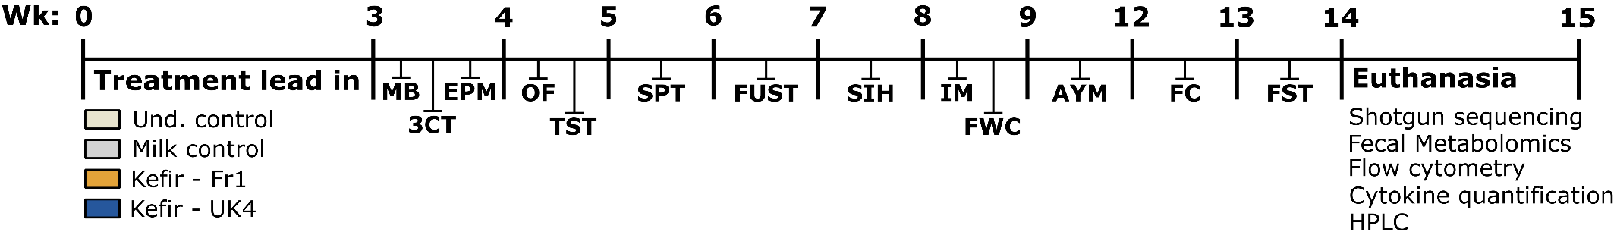
sFigure 1. Experimental design. After one week of treatment lead-in, animals were assessed for their behavioural phenotype. Treatment groups consisted of: 1) No gavage control, 2) Milk gavage control, 3) Kefir gavage – Fr1, and 4) Kefir gavage – UK4 (n = 12/group). The order of behavioural tests was as following; Week 4: Marble burying test (MB), 3-Chamber social interaction test (3CT) and Elevate plus maze (EPM); Week 5: Open field test (OF) and Tail suspension test (TST); Week 6: Saccharin preference test (SPT); Week 7: Female urine sniffing test (FUST); Week 8: Stress-induced hyperthermia test (SIH); Week 9: Intestinal motility test (IM) and Faecal water content assessment (FWC): Week 9-12: Appetitive Y-maze; Week 13: Fear conditioning; Week 14: Forced swim test; Week 15: Euthanasia. Postmortem, ileal, caecal and faecal microbiota composition and function was investigated by shotgun sequencing and faecal metabolomics. Host immunity was assessed using flow cytometry and by quantification of cytokines. Finally, ileum and colonic serotonergic levels were quantified by high-performance liquid chromatography (HPLC).

Figure S2. Room layout with cues for the appetitive Y-maze and food restriction. The room layout with the various cues used in the appetitive Y-maze is depicted (A). Mice were kept on food restriction of 90-95% of the free-feeding body weight. All data are expressed as mean ± SEM (n = 12).

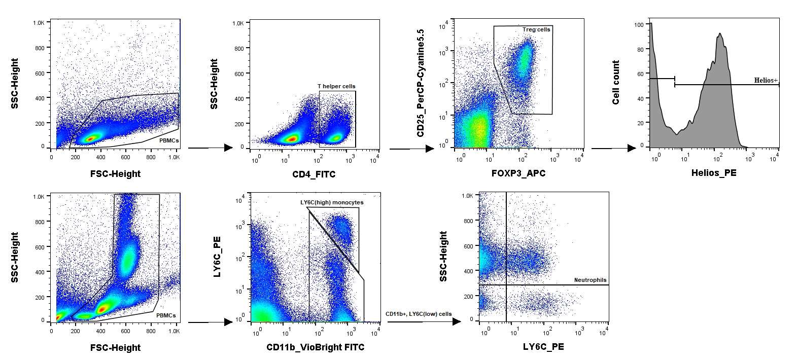
Figure S3: Flow cytometry gating of Treg cells, inflammatory monocytes and neutrophils. Cells (PBMCs) were selected based on FSC-height and SSC-height. The top four figures show the gating strategy for T regulatory (Treg: CD4+, CD25+, FOXP3+), whereas the bottom 3 graphs show the gating for monocytes (CD11b+, LY6C^{high}) (F) and neutrophils (CD11b+, LY6C^{mid}, SSC^{high}). T helper cells (CD4+) were subsequently selected based on CD4 receptor expressions and Treg cells were selected on CD25 receptor expression and FOXP3 transcription factor expression Finally, cells were analysed for the expression of the transcription factor Helios, as measure of their origin (i.e. periphery (pTreg). Monocytes were selected using LY6C and CD11b expression. Neutrophils were gated by first selecting CD11b+, LY6C^{-/mid} cells, after which SSC^{high}, LY6C^{mid} cells were selected.
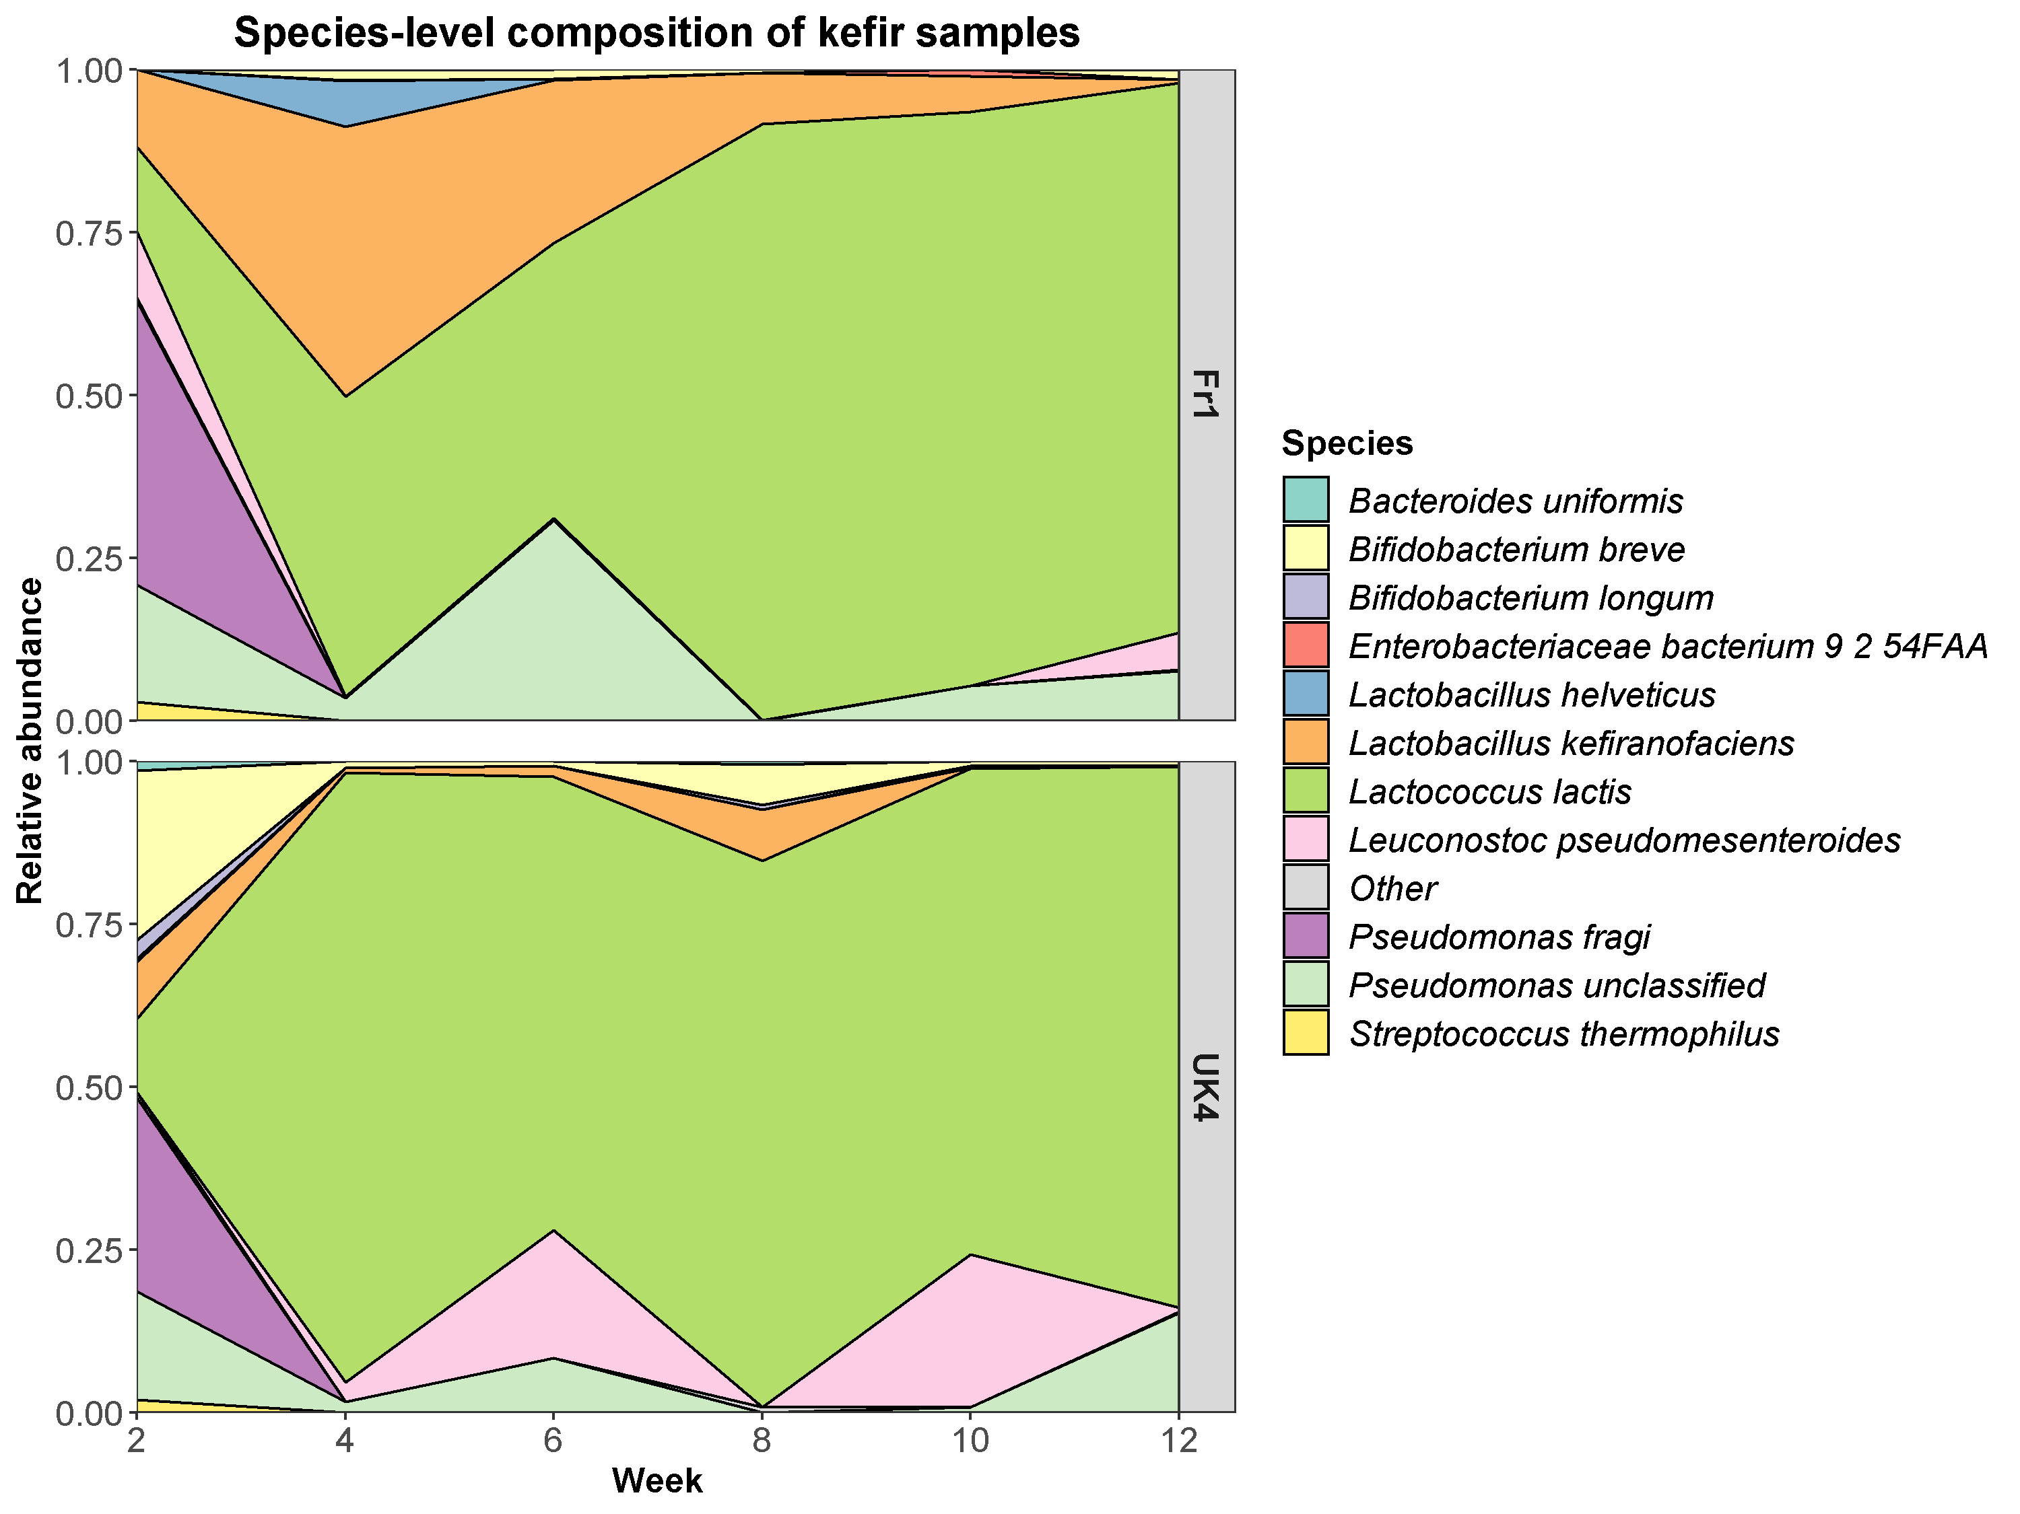
Figure S4. Stacked area chart showing the microbial composition of kefirs over the course of the experiment.
Figure S5. Kefir was well-tolerated in mice. Body weight as measured throughout the study (A). The gap in-between day 64 and 92 represents the appetitive Y-maze, in which animals were food restricted. Food intake and drinking water intake were measured during the habituation phase of the saccharin preference test (B, C). Body composition (i.e. lean, fat and fluid mass) were quantified at the end of the study (D-F). Basal body temperature was taken during the stress-induced hyperthermia test (G). Locomotor activity was assessed in the open field test. All data are expressed as mean ± SEM (n = 11-12). Dots on each graph represent individual animals.

Figure S6. Kefir did not influence gastrointestinal motility. Gastrointestinal motility was assessed by carmine red administration (A). Faecal pellet weight and water content were quantified during the “faecal water content assessment” (B, C). Caecum weight and colon length were measured at the end of the study (D, E). All data are expressed as mean ± SEM (n = 11-12). Dots on each graph represent individual animals.
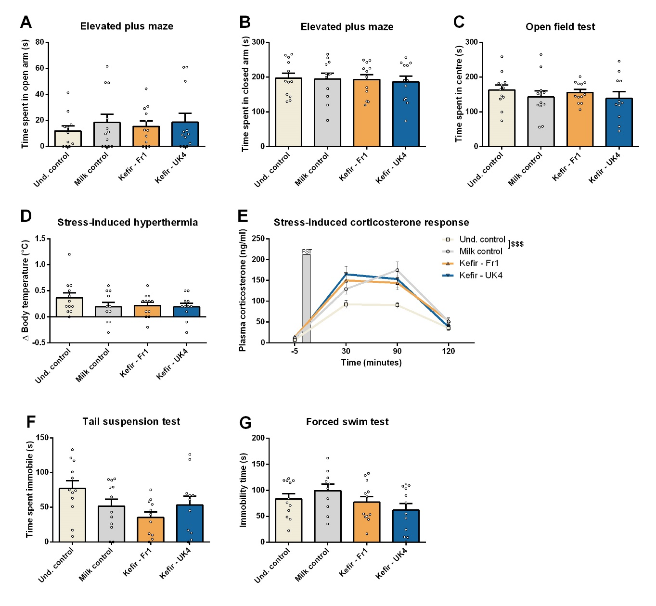
Figure S7. Selective anxiety-like and depressive-like behavioural measurement showed no differences. Repetitive/anxiety-like behaviour was assessed using the elevated plus maze and open field test (A, B, C). Stress-responsiveness was determined using the stress-induced hyperthermia test and by measuring corticosterone levels in response to an acute stressor (D,E). Depressive-like behaviour was investigated using the tail suspension test and forced swim test (F, G). Interestingly, the Milk control group did show an increase in stress-induced corticosterone response (F(1,20) = 15.936, p < 0.001), which was analysed using a repeated measures ANOVA. All data are expressed as mean ± SEM (n = 11-12). Dots on each graph represent individual animals.

Figure S8. Kefir did not influence social preference or recognition. Social preference and recognition were assessed with the 3-chamber social interaction test (A, B). The presence of social preference and recognition were assessed using a paired Student’s t-test. All data are expressed as mean ± SEM (n = 12).
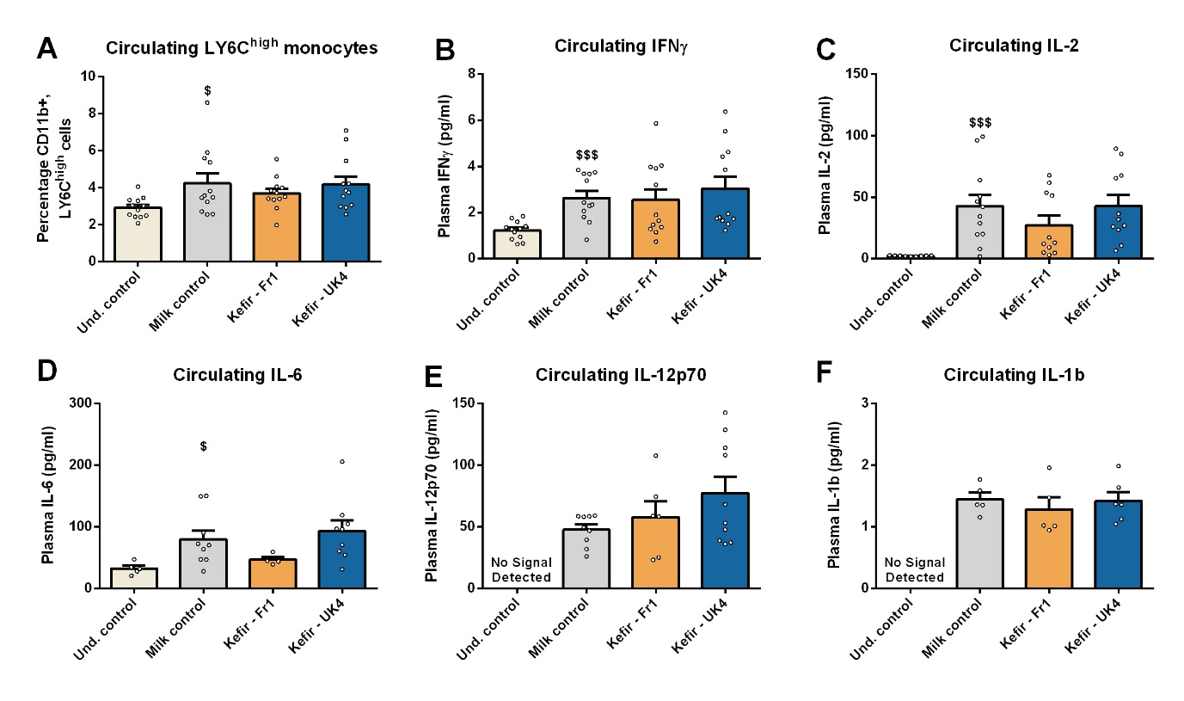
Figure S9. Mice receiving milk gavage show a low-grade systemic inflammation. LY6C_{high} monocytes were investigated at the end of the study using flow cytometry (A), see figure S2 for gating. Plasma cytokines (i.e. IL-2, IL-6, IL-12p70, IL-1β) were also quantified at the end of the study (B-F). Differences between Und. Control and Milk control were analysed using an unpaired Student’s t-test. The Milk control groups showed elevated levels of LY6C^{high} monocytes (t(22) = −2.437, p = 0.023), IFNγ (t(22) = −4.514, p < 0.001), IL-2 (t(19) = −3.838, p < 0.001), and IL-6 (t(12) = −2.354, p = 0.036). Similarly, no IL-12p70 and IL-1β were detected in the Und control group but were detected in several samples of the other groups. Values under the fit curve and detection limit were excluded from the cytokine analysis. All data are expressed as mean ± SEM. Dots on each graph represent individual animals
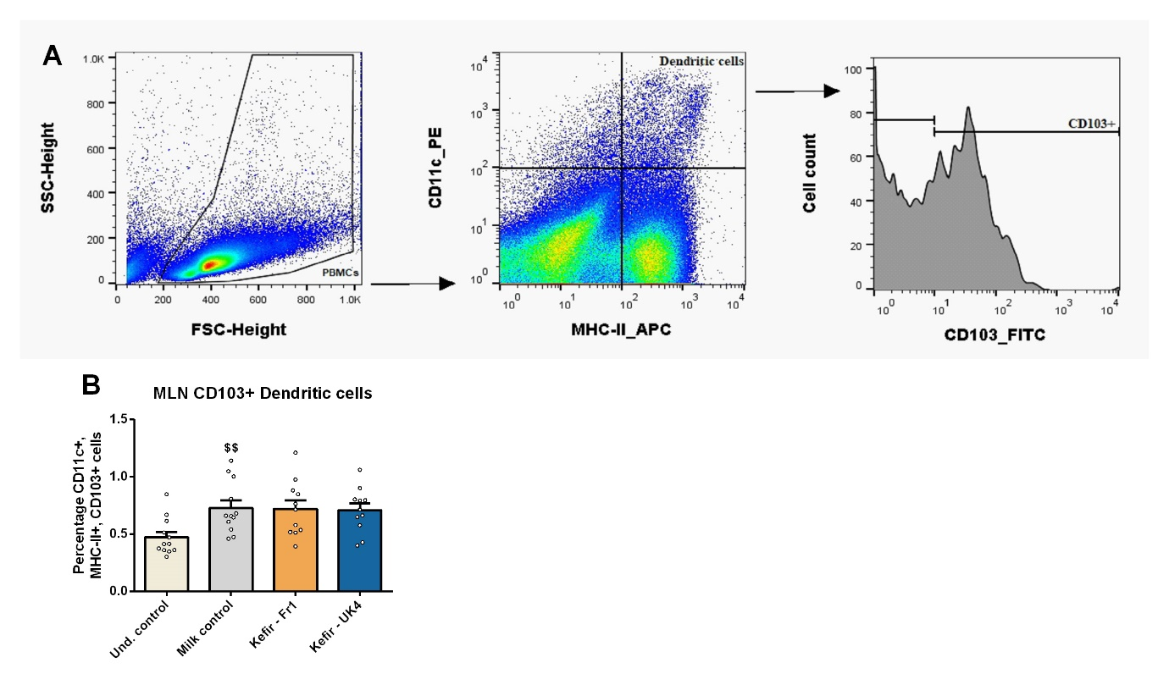
Figure S10. Kefir administration did not affect the prevalence of MLN CD103+ Dendritic cells. Mesenteric lymph node (MLN) CD103+ dendritic cells (CD11c+, MHC-II+, CD103+) were quantified using flow cytometry (A, B). Interestingly, the Milk control group did show increased levels of MLN CD103+ dendritic cells (t(22) = −3.165, p = 0.004), as analyzed by an unpaired Student’s t-test (B). All data are expressed as mean ± SEM (n = 12). Dots on each graph represent individual animals.
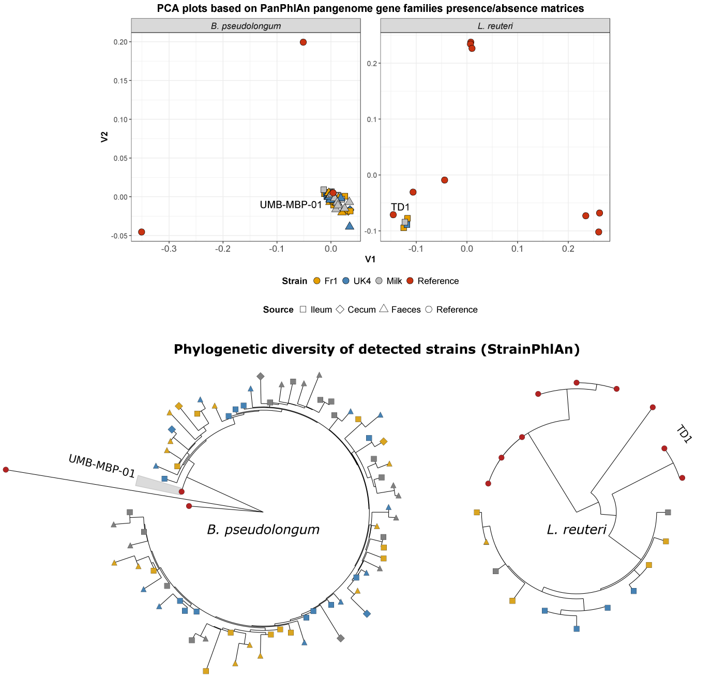
Figure S11. Strain-level analysis of Bifidobacterium pseudolongum and Lactobacillus reuteri detected in the mouse gut. (A) PCA plot based on gene families presence/absence matrices from PanPhlAn. The reference strains which shared the most gene families with that detected in the murine gastrointestinal tract are labelled. (B) Phylogenetic trees generated from StrainPhlAn outputs. Note that colours represent the group to which strains belong and shapes represent the source of the strains.
Figure S12: Faecal short-chain fatty acid levels were unaffected by kefir. The presence of enzymes involved in SCFA metabolism were detected in the kefir (e.g. Acetoacetyl-CoA reductase (EC: 1.1.1.36), Acetyl-CoA C-acetyltransferase (EC: 2.3.1.9), and Aconitate hydratase (EC: 4.2.1.3)) (data not shown). We subsequently analyzed the three principle SCFAs (acetate, propionate and butyrate) by chromatography–mass spectrometry, where no differences were observed. In addition, no changes were found in the predicted levels of SCFA-metabolizing enzymes in the gastrointestinal microbiota of mice receiving kefir. All data are expressed as mean ± SEM (n = 6). Dots on each graph represent individual animals.

Table S1: Reference genomes which were included in the custom PanPhlAn pangenome databases used in this study.
Species | Assembly | Strain
Lactobacillus reuteri | GCF_000010005 | JCM 1112
Lactobacillus reuteri | GCF_000016825 | DSM 20016
Lactobacillus reuteri | GCF_000159455 | SD2112
Lactobacillus reuteri | GCF_000236455 | ATCC 53608
Lactobacillus reuteri | GCF_000410995 | I5007
Lactobacillus reuteri | GCF_000439275 | TD1
Lactobacillus reuteri | GCF_001046835 | IRT
Lactobacillus reuteri | GCF_001618905 | ZLR003
Lactobacillus reuteri | GCF_001688685 | I49
Bifidobacterium pseudolongum | GCF_000800475 | PV8-2
Bifidobacterium pseudolongum | GCF_002282915 | UMB-MBP-01
Bifidobacterium pseudolongum | GCF_002706665 | DSM 20092

Table S2: Enzyme Commission (EC) level 4 categories which were differentially abundant between kefir versus Milk-fed mice, as determined by LEfSe.
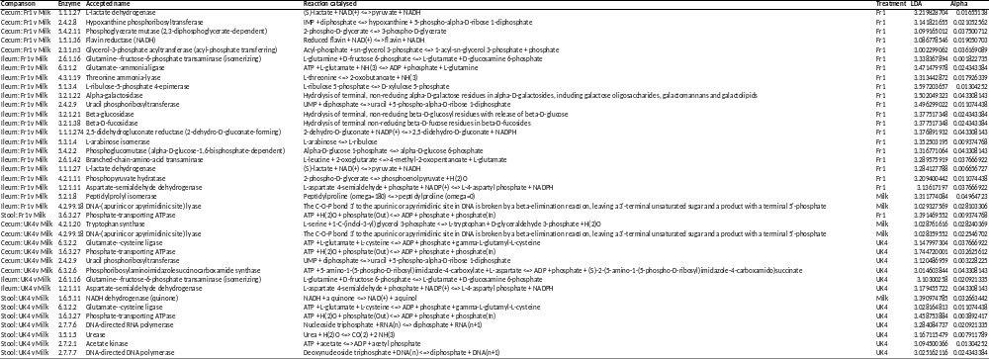
sTable 3. Faecal metabolomics. The faecal metabolome was assessed by as chromatography–mass spectrometry. Differences between undisturbed control and milk control were assessed for statistical significance using an unpaired Student’s t-test. The effect of kefir compared to milk was determined by a one-way ANOVA, followed by Dunnett's post hoc test. Significant differences are depicted as: $p < 0.05; Undisturbed control compared to milk control, *p < 0.05; Milk control compared to kefir. All data are expressed as mean ± SEM (n = 6).

 | Undisturbed Control |  | Milk control |  | Kefir - Fr1 |  | Kefir - UK4
 | Average (mM) | SEM | Average (mM) | SEM | Average (mM) | SEM | Average (mM) | SEM
Alanine | 0.65 | 0.15 | 0.51 | 0.18 | 0.58 | 0.24 | 0.75 | 0.37
Glycine | 0.20 | 0.05 | 0.23 | 0.10 | 0.16 | 0.07 | 0.29 | 0.23
Valine | 0.23 | 0.06 | 0.19 | 0.09 | 0.20 | 0.08 | 0.28 | 0.11
Leucine | 0.22 | 0.05 | 0.19 | 0.10 | 0.19 | 0.07 | 0.26 | 0.09
Isoleucine | 0.17 | 0.04 | 0.13 | 0.07 | 0.14 | 0.06 | 0.21 | 0.09
Threonine | 0.14 | 0.02 | 0.11 | 0.05 | 0.14 | 0.04 | 0.18* | 0.06
Proline | 0.13 | 0.02 | 0.11 | 0.04 | 0.11 | 0.03 | 0.15* | 0.04
Asparagine | 0.02 | 0.00 | 0.03 | 0.03 | 0.02 | 0.01 | 0.03 | 0.01
Glutamine | 0.44 | 0.21 | 0.17$ | 0.06 | 0.21 | 0.12 | 0.43 | 0.35
Serine | 0.19 | 0.02 | 0.18 | 0.07 | 0.19 | 0.06 | 0.22 | 0.06
Glutamic acid | 1.05 | 0.38 | 0.64 | 0.22 | 0.68 | 0.45 | 1.13 | 0.93
Methionine | 0.07 | 0.03 | 0.05 | 0.03 | 0.06 | 0.03 | 0.09 | 0.06
Phenylalanine | 0.10 | 0.03 | 0.08 | 0.04 | 0.09 | 0.03 | 0.13* | 0.05
Ornithine | 0.05 | 0.01 | 0.03$ | 0.01 | 0.05* | 0.01 | 0.06 | 0.02
Lysine | 0.36 | 0.10 | 0.22$ | 0.08 | 0.27 | 0.16 | 0.38* | 0.21
Histidine | 1.26 | 0.16 | 0.61$ | 0.23 | 0.98* | 0.30 | 1.15 | 0.49
Tyrosine | 0.10 | 0.03 | 0.08 | 0.03 | 0.09 | 0.04 | 0.12* | 0.05
Aspartic acid | 0.12 | 0.03 | 0.12 | 0.08 | 0.11 | 0.04 | 0.15 | 0.03
Pyruvic acid | 1.18 | 0.60 | 0.74 | 0.22 | 0.92 | 0.61 | 1.92 | 1.43
Succinic acid | 0.72 | 0.25 | 0.47 | 0.12 | 0.84* | 0.43 | 0.75* | 0.25
Fumaric acid | 0.06 | 0.02 | 0.04$ | 0.01 | 0.06 | 0.02 | 0.06* | 0.01
Lactic acid | 0.99 | 0.83 | 1.41 | 1.25 | 3.60 | 2.60 | 1.24 | 0.70
Malic acid | 0.36 | 0.04 | 0.26$ | 0.05 | 0.34* | 0.04 | 0.46 | 0.18
2-oxoglutarate | 0.45 | 0.28 | 0.27 | 0.09 | 0.23 | 0.24 | 0.72 | 1.02
Isocitric acid | 0.04 | 0.00 | 0.04 | 0.00 | 0.04 | 0.00 | 0.04 | 0.00
Citric acid | 0.06 | 0.02 | 0.04$ | 0.01 | 0.05 | 0.01 | 0.05 | 0.01
Octanoic acid (C8:0) | 1.18 | 0.32 | 1.08 | 0.37 | 1.34 | 0.31 | 1.45 | 0.51
Nonanoic acid (C9:0) | 1.13 | 0.36 | 1.33 | 0.52 | 1.40 | 0.30 | 1.59 | 0.51
Malonic acid | 0.91 | 0.08 | 0.74$ | 0.11 | 0.84 | 0.11 | 0.90 | 0.18
Phenylacetic acid | 0.95 | 0.55 | 0.49 | 0.21 | 0.52 | 0.23 | 0.80 | 0.49
4-Hydroxyphenylacetic acid | 0.08 | 0.01 | 0.07 | 0.03 | 0.07 | 0.02 | 0.07 | 0.02

